2024 Holiday Decorating Contest
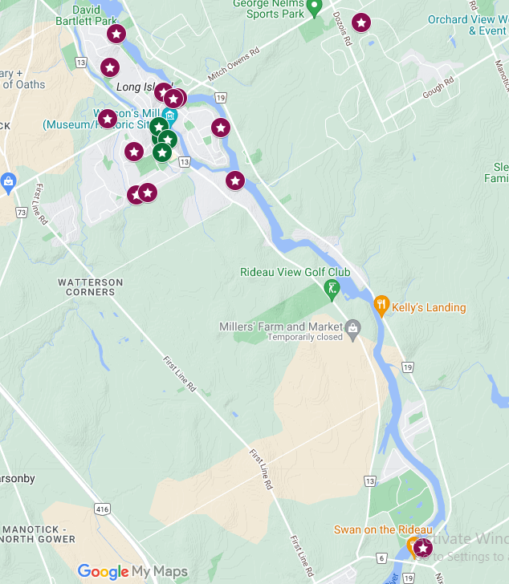
Businesses:
Manotick Place Retirement Community
1145 Bridge Street

Allure Hair Design & Spa
1145 Mill Street

Lume Club
1138 Tighe Street

Royal LePage Team Realty
5336 Manotick Main Street

The Mill Tavern
5544 Manotick Main Street

Mansfield Shoes
1160 Beaverwood Road

Residences
2712 River Road

1104 Meadowshire Way
458 Lockmaster Crescent
1220 Beaverwood Road
1275 Potter Drive
1250 Potter Drive
1081 Island View Drive
5577 South Island Park Drive
5471 North Riverside Drive
5466 North Riverside Drive
1063 Bravar Drive
1160 Jean Park Road
5443 Riverside Crescent

